IT5106 - Software Development Project
Progress Report – 3
Academic Year - 2025

Project Identification Information
Project title | : Wedding and Event Management System for Chance Palace Hotel Group
Student’s name with initials | : W. A. A. D. Wijesingha
Index no. | : 2014173
Supervisor’s name | : Ranula Gihara Gamage

Progress Report Period
Start Date: 2nd February 2026 | End Date: 3rd March 2026
Work Carried out between this meeting and previous meeting
Problems Encountered
Planned work that were unable to carry out with reasons
Work planned until next meeting

Supervisor’s Comments
Student has done |  |  |  |  | work.
  X | More than enough |  | Sufficient |  | Not Enough |  | No
Student is progressing |  |  |  |  | in the project.
   | Well ahead | X | Sufficiently |  | Not Enough
Further Comments (if any)
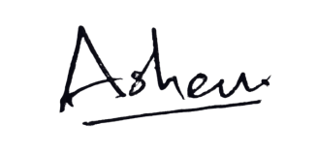 |  |  |  | 
Student’s Signature |  |  |  | Supervisor’s Signature

